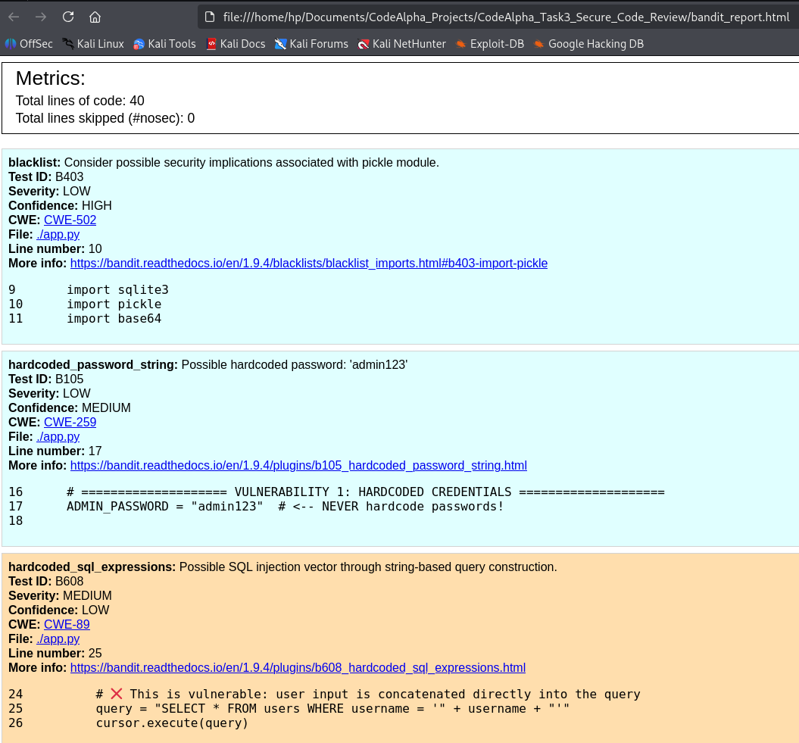
Figure 1: Bandit SAST Scan Results. Bandit scans the vulnerable app.py and identifies six security issues, including Hardcoded Credentials (B105), SQL Injection (B608), Insecure Deserialization (B301/B403), and Debug Mode enabled (B201). The B201 finding is rated HIGH because it exposes the application to remote code execution.

Figure 2: Manual Code Review – Hardcoded Credentials. The line ADMIN_PASSWORD = "admin123" is flagged by Bandit (B105) as a hardcoded credential. An attacker with source code access can immediately compromise the application. The fix is to use environment variables.
“
X
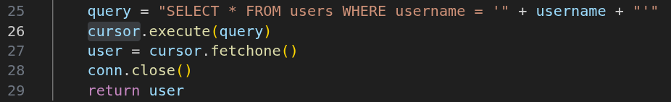

“

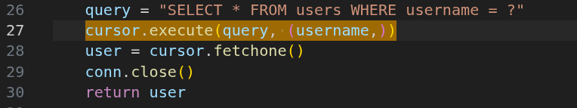
Figure 3: Remediation – Parameterized Query. The fixed code uses a parameterized query (cursor.execute(query, (username,))). This treats user input as data, not executable code, completely neutralizing SQL Injection attacks (CWE-89).

